4th National Summit on Episodic Disability and Employment March 20 and 21, 2024
Keynote Speakers
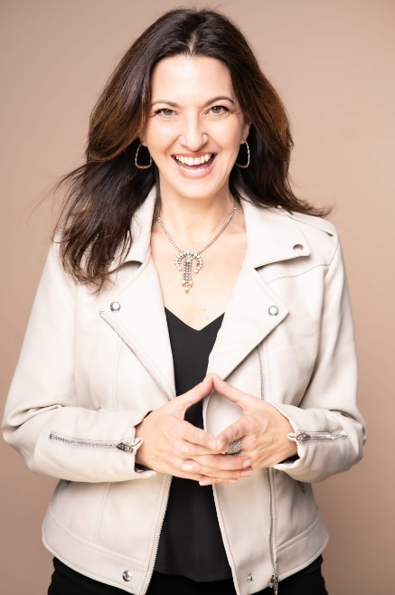
Tracey Erin Smith
Tracey Erin Smith is an internationally recognized theatre and television creator. She is the founder and driver of SOULO Theatre, originating in Toronto, with workshops in New York City, Tel Aviv, San Francisco, Vancouver, and the UK. Tracey is an award-winning teacher, solo performer, director and thought leader employing personal stories for transformation. Her work has been seen Off-Broadway and has been awarded Best of The Fringe for her solo shows The Burning Bush! and The Big House (NYC / Toronto), Broadway World Award (NYC), the Audience Choice Award (NYC) and most recently she received the INSPIRE Lifetime Achievement Award. Tracey is also the host and creator of the award-winning documentary television series DRAG HEALS (OUTtv, AmazonPrime, AppleTV). Tracey is hard at work on her first book Flying SOULO due out in the fall 2024. She loves working with Realize!!
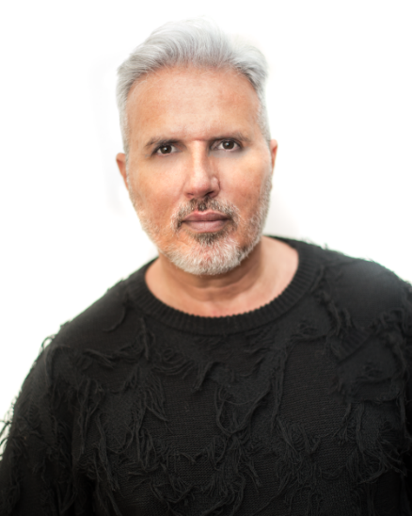
Shaun Proulx
Shaun Proulx is one of the most versatile talents in media and entertainment today. He has credits as a television personality and host, producer, talk radio host, motivational speaker, columnist, author, publisher, actor, live event host, spokesperson, life coach, and activist for the issues of mental health, animal rights, and HIV stigma. Shaun is producing a soon-to-be launched podcast for Realize focused on episodic disabilities and nurturing potential inclusion and belonging for all.

Speakers and Panelists
Anna-Liza Badaloo
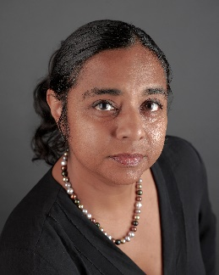
Anna-Liza Badaloo (She/Her) is the Founder of Anemochory Consulting, an organizational justice practice. She helps organizations uncover how colonial harms show up in the workplace. By leveraging empathy with a decolonized, intersectional lens, she amplifies traditionally silenced voices and fosters inclusive workplaces where all employees feel a sense of belonging.

Dr. Monique Gignac
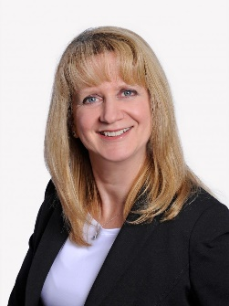
Dr. Monique Gignac is scientific director and senior scientist at the Institute for Work & Health. She is also a professor in the Dalla Lana School of Public Health at the University of Toronto. Gignac’s research expertise is in the areas of health and social psychology, including health models of disability. Her research examines psychosocial factors like stress, coping, adaptation and communication, and their importance in understanding the impact of chronic diseases on the lives of adults across the life course. Of particular interest is research on workplace communication, privacy, support, and accommodation needs among individuals living with chronic, episodic conditions.
Christina Chan, R.Ac.
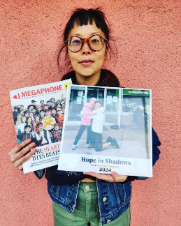
Christina (she/her) is a Community Acupuncturist, community organizer, educator, rider of many things with 2 wheels, martial artist, immunocompromised lupus survivor and high functioning spoonie. In 2006, Christina became certified as an National Acupuncture Detox Association (NADA) provider. Then, in 2009, she completed her training as a Registered Acupuncturist at the Canadian College of Acupuncture and Oriental Medicine (CCAOM) in Victoria, BC.
Christina is a Balance Method practitioner, training in the system since 2010, initially with the late Dr. Richard Teh-Fu Tan, Si Yuan Balance Acupuncture based in the EU and in November 2023, completed the Balance System Acupuncture certification with Gold Level certified Dr. Sonia Tan, based in Vancouver, BC.
She is also a certified Cranial Sacral Therapist, completing her training in 2011, through the Department of Holistic Health Studies at Langara College in Vancouver, BC. In a previous lifetime, she completed a Master’s in Human Physiology in 2005, specializing in Cardiovascular Cell Biology at Queen’s University in Kingston, ON.
She has practiced her craft in a variety of settings including at the Vancouver Daytox, Indigenous Wellness Week at UVic’s First People’s House, Motherfest at Mothering Touch, Fernfest, Victoria’s Annual Anarchist Book Fair and AIDS Vancouver Island.
Active in the community, she is passionate about using acupuncture as a tool for positive social change through providing outreach, increasing accessibility and bringing the practice back to its traditional roots. She continues to explore her own personal experiences as a woman of colour living with chronic illness, community organizer, and founder of an unorthodox social enterprise in Lekwungen Territories, otherwise known as Victoria BC.
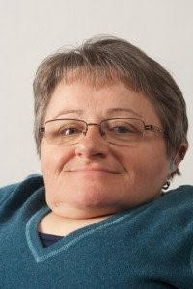
Fran Odette (she/her)
Fran Odette teaches in the School of Social and Community Services at George Brown College. She has 25+ years of disability activism and education. She has made scholarly contributions to addressing inequities in health, community and anti-violence services for women and children living with disabilities.
Fran comes to this work from her own lived experience and as someone who is committed to advocating that people with disabilities live their lives with self-determination and agency. She works closely with service providers, including health care practitioners who work with marginalized communities, to ensure that programs reflect a human rights perspective, which includes working from a place of respect and dignity. She has delivered workshops with a focus on social justice, disability and inclusion to audiences both provincially and nationally. Fran teaches a critical disability studies course at George Brown College.
Jacob Love
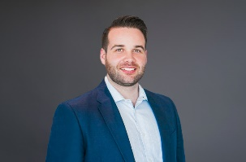
Jacob takes a practical approach to resolving workplace issues. He understands that every workplace is different, and he works with both unionized and non-unionized employers to craft workplace solutions tailored to each client’s unique needs.
Jacob has experience representing employers in matters of wrongful/constructive dismissal, workplace harassment and bullying, human rights complaints, grievance arbitration and OHSA charges. Jacob also has extensive experience assisting employers with workplace policies and employment agreements.
Jacob completed his articles with the firm in 2019. Prior to returning to the firm as an associate in 2022, Jacob worked with other labour and employment law firms located in Hamilton and Toronto. Jacob received his J.D. from Queen’s University, where he also won the course prize for Civil Procedure. He completed an M.A. in political science from Carleton University, and a B.A. with honours in politics and a second major in philosophy at Acadia University.

Lys LeClair
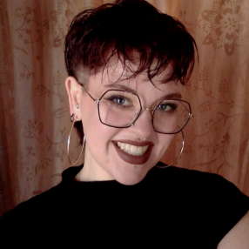
Lys LeClair (they/them) is a neurodivergent interdisciplinary artist and advocate for disability rights. Through their work in the arts, writing, and performance, they strive to raise awareness about disability & accessibility rights, queer politics, destigmatizing mental health, and addressing current humanitarian issues. With a deeply community-focused approach driven by a commitment to mutual aid and community care, Lys draws inspiration from their own lived experiences as well as the stories and experiences of their communities. Their aim is to create works and environments that encourage viewers to witness, learn, and understand the realities faced by marginalized groups and individuals.
Misbah Anis

Misbah Anis joined CCPartners as an associate in 2023 after completing her articles at a prominent labour & employment firm in Toronto. Misbah advises and represents clients on a wide range of labour and employment issues including employment contracts and policies, discipline and termination, human rights and labour relations.
Misbah received her Juris Doctor from University of Windsor, where she was the president of the Labour & Employment Law Society. While in law school, Misbah worked as a student caseworker at the Windsor Legal Aid Clinic, representing low-income clients in a variety of matters. Prior to law school, Misbah worked in human resources gaining valuable experience with a variety of workplace matters.
In her spare time, Misbah enjoys working out, travelling and trying out local coffee shops.
Odelia Bay
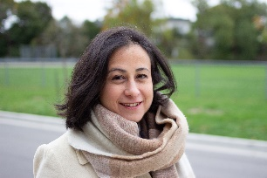
Odelia Bay is a lawyer, academic, and advocate who identifies as episodically disabled.

Odelia is currently working towards her PhD at Osgoode Hall Law School. Her doctoral research examines how workers with episodic disabilities balance the competing needs of self-care and work. She has published on these themes in Canada, the United States, and the United Kingdom, most notably as a co-author of Law and Disability in Canada: Cases and Materials (LexisNexis, 2021), the first disability law casebook in Canada.

Before starting her doctorate, Odelia completed her LLM at Columbia Law School, where she was awarded a Graduate Student Fellowship with the Future of Disability Studies Project at Columbia University. She also holds a Juris Doctor in English Common Law from the University of Ottawa and a Bachelor of Journalism from Toronto Metropolitan University.

Odelia articled in union-side labour law and is called to the Ontario Bar. She has taught several law school courses including labour law and critical race theory. Prior to studying law, Odelia worked as a broadcast journalist in both radio and television.

Parnika Celly
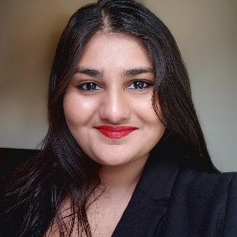
Parnika is the Newcomer Youth Mental Health Settlement Worker at the Newcomer Youth Program at West Neighbourhood House. In her role, she focuses on providing mental health support and psychoeducation in creative ways to youth who are new to Canada, particularly through the arts and through virtual formats. Parnika earned her HBSc in Psychology, Anthropology, and Theatre & Drama Studies from the University of Toronto, as well as an MSW with an emphasis on Global Social Work and Social Development from Rutgers University. Parnika's journey with supporting Disability Justice is rooted in personal experience and has been informed by courses as well as professional experiences. She is grateful to have the opportunity to work alongside and continue learning from her amazing colleagues at the Disability Justice Affinity Group at Toronto Neighbourhood Centres.
Raheme Perry
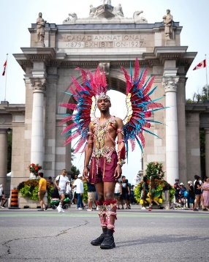
As a queer person of color who has been diagnosed with Chronic Schizophrenia and Depression, I have experienced many challenges navigating my treatment and care. I am no stranger to stigma; having been bullied and harassed because of a diagnosis that very few people can comprehend. Like many others, I have been misdiagnosed on multiple occasions by different psychiatrists.
I decided to launch “Peer Stories” first named “Lead with Hope” with funding from the Community One Foundation to destigmatize mental health and offer support and resources to persons who have experienced similar mental health challenges as I have. In the past year, I held wellness workshops and developed multiple websites from cosmetics to social services and construction. As opportunities arise, I want to use my voice for those who, just as I thought, don’t believe they do.
I know that I am not alone. I hope that through sharing my lived experience, others who experience similar mental health challenges can see their reflections in my story and create a sense of community. While I still face challenges but have found somewhat stable ground through the storm that occupies my mind. I am no longer afraid to share my story. My hope is to challenge the stigma and systems that do not fully understand what it is like to live with chronic schizophrenia.

Susan Wallace – Section chief, Disability and Accessibility Statistics
Susan (she/her) is the manager responsible for the Canadian Survey on Disability, as well as other projects related to disability and accessibility statistics. Susan has been with the Disability and Accessibility Statistics section since 2020, and at Statistics Canada since 2006.
Melissa Egan - National Lead, Episodic Disabilities, Realize
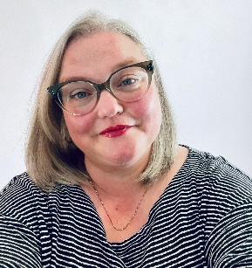
Melissa Egan is the National Lead, Episodic Disabilities at Realize and has been with the organization since 2019. She has worked in the field of health education for over 20 years as a presenter and facilitator, developing and delivering trainings to diverse audiences across Canada. She has experience using community-engaged research evidence to inform education and believes this is vital in creating lasting practice change. Melissa brings a commitment to inclusion, diversity, equity, and accessibility to her work and has worked extensively with the 2SLGBTQIA+ community, and Indigenous people. Melissa holds a BA and a BEd and has recently completed a Master of Education.

